

Presents…

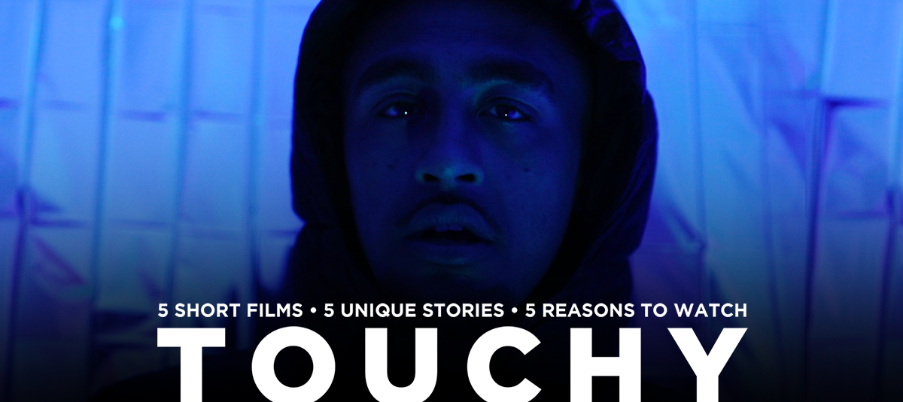

Self-care toolkit
Commissioned by Wellcome Collection
In association with Unity

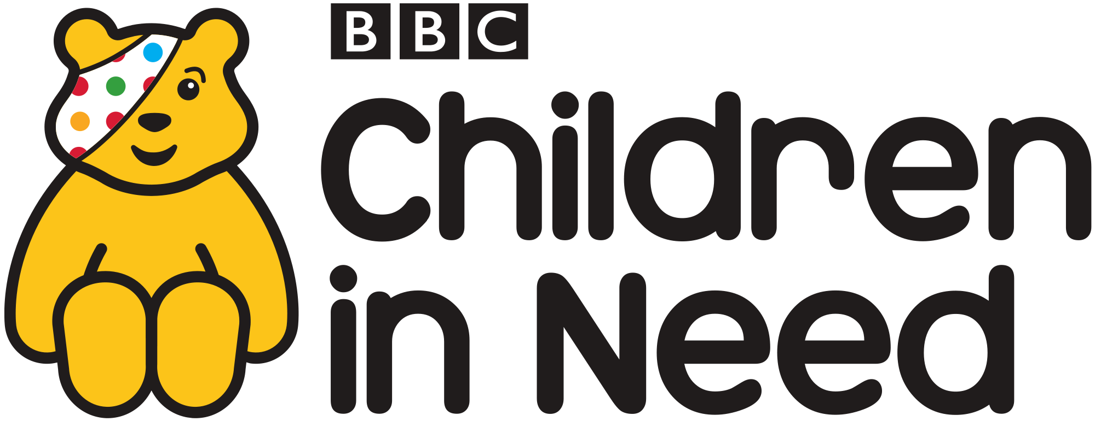

   | 

TOUCHY
Five short films, five unique stories, five reasons to watch.

Touchy is a project made by 20 Stories High in collaboration with six Liverpool-based artists. In May 2021, we’ll release each film weekly, and they will be available to watch on YouTube and Instagram for a while after. We start with Jemell’s story – which this toolkit supports, moving through the weeks to Max’s story at the end.
Self-care toolkits are available for all five films (or as one combined toolkit) from our website: www.20storieshigh.org.uk

About Touchy
A mash up of theatre and music video – interweaving beats, drama, poetry, animation, visuals and original music. We follow the journey of six characters as they navigate their way through the tactile highs and lows of young adulthood.

Jemell’s Story blends Hip-Hop and storytelling to tell the story of a young Black lad living with undiagnosed autism.

Jazz’s Story is a tender and uplifting R’n’B love story exploring public displays of affection in a same sex relationship.

Ella and Ste’s Story investigates consent, with a story that explores the conflicting recollections of an intimate moment from many moons ago.

Sophie’s Story explores how a young woman renegotiates her relationship with her Grandad Kojo during lockdown.

And finally, in Max’s Story, a young trans guy guides us through his discoveries around social touch with a funny and heart-warming animation.

Co-created with a multi-talented collection of rappers, singers’ actors, poets, beatmakers, writers, visual artists, animators. Touchy offers a unique exploration in the world of touch.

Content Overviews
Jemell’s story contains themes of racism, mental health and substance abuse. Also contains strong language and the use of the "N" word.
Jazz’s story contains themes of same-sex relationships and romantic touch in public spaces.
Ella & Ste’s story explores sex, relationships and questions around sexual consent and assault.
Sophie’s story explores family relationships, COVID-19 lockdown and how the pandemic has impacted families.
Max’s story is told through an accessible and light-hearted animation. It explores social touch, gender identity and the experience of transitioning.

There are detailed breakdowns of what happens in each film further down in this pack.

Suitable for ages 13 plus.

Why this toolkit?
This toolkit has been designed to offer support to anyone engaging with the film, especially anyone who might be impacted by its content. We hope this toolkit provides you with specialist resources and tools from the professionals that may help.

Tips – how to look after yourself
- Go at your own pace: If you don’t want to watch this all at once, maybe consider watching the film a bit at a time. Jemell’s story is in three parts and is nine minutes long in total. It’ll be available on YouTube and Instagram for the next few years at least. Do what feels right for you.
- Watch with someone: Watching with someone who knows you and any connections you may have to the theme of this film may help when it comes to recognising if you need to switch it off, or if you need support. Or if you can’t watch with someone, maybe message someone ahead of watching, and let them know you might call them if you need support.
- Read a summary of the film: If you’d like to know the content before you watch, so that there’s nothing unexpected, you’ll find at the bottom of this document a full breakdown of the piece.
- Remember it’s your choice: Remember it’s your choice to watch this film – you’re in the driving seat – there should never be any pressure to do so. You are in control, even if you might not feel it. If you’re feeling overwhelmed at any point, turn it off and try some grounding techniques.
- Remember your breath: If you become triggered, breathing is a great way to bring yourself back into a state of calm, lower your heart rate and create space in your brain to start thinking things through at an easier pace. Try breathing in for four seconds, holding your breath for four seconds, exhaling for four seconds and holding again. Repeat this for as long as you need until your breath feels in control again. Lots of mobiles & smart watches offer apps which can help you with this.
- Get some fresh air: Going for a walk or even just standing outdoors can help.

Get help: If you notice that you’ve become overwhelmed and the techniques suggested here, and the ways you usually bring yourself back into a state of calm, then recognise that moment, and consider getting professional support. See the bottom of this document for helplines and organisations who can help.

Advice taken from The Survivor’s Trust blog: Taking Care of yourself & I May Destroy You – find more advice and tips here: https://bit.ly/3v6rw2H - this article was created by The Survivor’s Trust in order to help viewers in making the choice to watch the TV series I May Destroy You. Although our Touchy films have differing themes, the ideas and tips are relevant for lots of shows and films that may be triggering.

Synopsis of the Films:
Jemell’s story
Jemell’s story is a mix of spoken word and rap, and he speaks in third person throughout the piece.

We start with Jemell performing against a background of plastic bubble wrap, as if in a music video. He is recalling about what it was like growing up for him – noticing that daily tasks and interactions are difficult for him. He starts to realise that he feels ‘different’ to others – both on the inside and out.

We then see Jemell sat in a stake park, reflecting on his teenage years. He talks about how his ‘constant tapping’ was annoying to everyone – his family, peers at school and teachers. Jemell highlights one teacher that was different from the rest – Mr Jones – who Jemell felt understood Jemell’s needs and could see the potential in Jemell as a musician and creative.

Jemell recalls a moment where Mr Jones gives Jemell an ‘SP 404’ – which is a small, box-shaped sampler which is used by musicians to create sounds and music. We see many SP 404s rain from the sky visually. Jemell describes the bond he felt with Mr Jones as a result of finally feeling understood by someone.

Jemell talks about how he really took to creating music: ‘there was no turning back’. He goes on to talk about how other young people in school would get jealous, and that they couldn’t understand Jemell. Jemell talks about how his social interactions with peers became violent – no longer arguing but fighting, which resulted in Jemell being excluded from school. This meant Jemell could no longer use the SP 404 in school, and so he would no longer make music. With nothing positive left for Jemell, he describes how he becomes ‘a reckless individual’.

We then seen Jemell back in his music video mode, against a shiny background. The next rap talks about Jemell’s struggles after being excluded – his anger problems, family & relationship issues and his substance abuse. Jemell talks about his struggles through a medical assessment – and how he felt that he wasn’t fitting the stereotypes that society wanted to place upon him.

We then move to Jemell at the beach. He talks about how this ‘reckless’ time of his life affected his mental health, causing him to become withdrawn and suffering with depression. We then hear of a turning point in Jemell’s life which was his brother moving back home – who was able to help Jemell back in the ‘right direction’ – helping him to feel understood and confident about his identity and recognising his neurodiversity. With this new support, Jemell tells us about how he got a job in a shop that supports his needs properly, and the difference this had made to him. With the money from his job, Jemell buys himself an SP 404 to make music.

We visually see Jemell live streaming a jam session on his SP404 – creating bouncing hip hop melodic beats. He looks at home and comfortable with where he’s at.

Jemell finishes his story by doing a shout to all the high-flying individuals on the spectrum – and reads out a list of celebrities who have been diagnosed or are suspect to have/had autism.

Jazz’s story
Jazz’s story is told through a duet in a R’n’B music video. It explores public displays of affection in a same sex relationship.

We start with Jazz sat in a park. The scenes cut between the park and her room – her creative space. She sings about needing her girlfriend’s touch, the small signs of affection that display their love in public. She sings about wanting to escape ‘unwanted attention’ but also the desire to be physically close and connected – a sign of love.

The chorus recites Jazz’s need, and want, to be touched. She sings about how this public display of affection makes Jazz feel loved and needed.

Jazz continues to explore their relationship and asks, ‘am I a phase?’, she sings about how her partners’ family assume that she is straight. Jazz recognises that this is a sensitive topic – she does not want to take over her partners ‘space’ to come out to her own family. Jazz questions about slowing the tempo.

We return to the chorus (as above), and Jazz ends her verses by asking her partner to ‘Touch me, reciprocate the feeling’. Jazz knows that her partner wants to.

The second part of the song is sang by Cat, responding to Jazz. We don’t see Cat – just a shadow of her. She asks ‘why do we live dangerously?’ and replies to Jazz by saying she cares about being affectionate in public with her because people stare. Cat sings about feeling euphoric when they do show their love in public. She reworks Jazz’s chorus, appreciating that Jazz led the way and she now feels at ease. At this point, we see Jazz’s shadow enter Cat’s space. They embrace, and dance and show affection.

We then see submissions which were sent in my female-identifying people in same-sex relationships. These are a mixture of artwork, personal videos and pictures. They are all celebratory of the lesbian, same-sex relationship community.

Cat’s verse finishes with a repetition of her request to compromise and take time for them to find their own way.

The music video finishes with a dedication to all the women who are navigating same-sex romantic touch in public spaces. It reminds us that we have time to reach out our hands, to understand one another. It recognises the generational ‘radicalness’ of same-sex couples showing affection in public spaces. The song finishes by reflecting on Cat’s final request – to take time and learn how to give, receive, and support public displays of affection in same-sex relationships.

Ella and Ste’s story
Ella and Ste’s story is told through two conflicting recollections of an intimate moment many moons ago. It investigates consent, and what mutual desire does - and does not - feel like.

The piece starts with Ste and Ella looking directly into the camera – both of their voices are heard saying ‘shit’. Ella starts talking about how something had happened, that she had not wanted. There is cello music playing in the background. The film cuts to Ste sitting in the courtyard of a bar. Ella’s face is superimposed over this scene, and she is looking directly into the camera.

We realise that Ste has just seen Ella for the first time in 10 years in a bar he is at with friends. Ella is in a bed on the night they last saw each other, 10 years ago.

Ste is alone and talks about how he would greet Ella if he bumped into her – how he imagined it would be when they next saw each other. He talks about how he would ask Ella why she has ‘ghosted’ him for the past ten years, and why she never got in touch. The image of Ste slowly fades, and Ella is looking directly into the camera. He talks about how it was difficult for him to understand that night, why she left and how it has impacted him. He feels like he is owed an explanation.

There is a loud white noise, the screen flashes black and white, and Ella is lying in bed. The shot only shows her shoulders and head, lay on a light pink pillow, with a faded rainbow. She looks directly into the camera and says: ‘I am trying to piece together what happened’. The film returns to Ste sat outside the bar, he imagines that if he saw Ella, she would apologise. The screen flashes and returns to Ella in bed. She says that she is sober now and angry with herself.

The piece returns to Ste, he imagines that they would reconcile, hug and maybe even fall back in love. Ella starts to talk through what she remembers from the evening. They are staying in Maya’s sister’s room, covered in unicorns and rainbows. They start kissing and Ella talks about how her and Ste share the same values - they had discussed waiting to have sex - Ste is a Christian and didn’t want to have sex before marriage and she wanted to wait.

The scene returns to Ste in the bar. He recites a conversation that he had been having with his friend who talks disrespectfully about women. Then, Ste sees Ella. She is standing in the bar. The screen flashes to Ella in bed. She talks about how her and Ste are undressing each other and how it feels comfortable, especially because of the alcohol. Ella talks about how they touch each other, as they would normally, but then Ste climbs on top of her. They had not agreed, but he penetrates her. As they look into each other’s eyes, Ella does not know what he is thinking. She recalls that ‘they might as well carry on’ as they had done it now. She feels like her head is full of Prosecco and mess.

Their voices start cutting over each other – Ella thinks Ste can see that she is uncomfortable. Ste talks about how he asked if Ella was okay - because she doesn’t look okay. Ste thinks this is a deep, intimate moment. Now, years later, he sees that maybe it is not what she wanted. Ella questions why she isn’t telling Ste to stop - and why Ste didn’t ask her in the first place. Returning to present day, Ste talks about how he can see the same look in Ella’s eyes, stood outside the bar, that he saw on that night.

The film returns to Ella lay in bed, she doesn’t feel comfortable with Ste snuggling into her and being soppy. Ella talks about how she feels angry with herself, and that she has let herself down. Why did she let him? She wants to get out. Musical symbols build in the background. Ste is sat outside the bar. He realises what happened on that night and talks about how he should have asked Ella for consent.

The piece moves to Ella stood in front of a mirror in the bathroom, shortly after the party and the moment in bed with Ste. She is taking her earrings out and talking about how that night made her feel. She doesn’t know exactly what it was, but she does know that it didn’t feel comfortable. She didn’t know what to tell him, but she knew that they were over. One day she will tell him.

The piece moves to Ella stood in the courtyard of the bar, where Ste is, in present day. Ste talks about how her expression changes, it focuses. The piece finishes with Ella looking directly into the camera and asking, ‘Ste, can I have a word?’. The background music has changed, it is light and steady, the camera fades.

Sophie’s story

Sophie’s Story explores how a young woman renegotiates her relationship with her Grandad Kojo during the COVID-19 lockdown.

The film begins with a variety of illustrations and artwork which relate in some way to Sophie and her world. Soft, slow music is playing. The film moves to a woman, sat on a red chair, reading from a book. We see the words she is reading on the left-hand side of the page. She narrates a poem about Sophie and talks of how lockdown has changed plans and caused feelings of isolation and loneliness. An illustration of a landscape of a starry night, clouds, and event tickets are shown and the narrator talks about how the plan for 2020 was to take Kojo on a surprise trip to Africa.

The story returns to the narrator sat in chair. She talks about Sophie as a key worker and highlights that her favourite person has always been her grandad – Kojo. The film moves to an illustration of the world, spinning, and then an illustration of Sophie and Kojo as they look up at the sky. Love hearts soon fill the screen as we hear more about their close and special relationship. Sophie spent more time with Kojo than at home.

We hear that Kojo moved from Ghana to Liverpool at the age of eighteen, images of old photos from Ghana that Kojo used to show Sophie come up, the same images which inspired Sophie to book a surprise return trip in 2020. We return to the narrator, who explains that due to the COVID-19 pandemic, the surprise trip to Africa became a no go. The narrator talks about an even bigger challenge due to the pandemic - being separated from her beloved Kojo. We see the illustration of Sophie and Kojo on the screen, arms coming out to touch each other but in their separate colourful boxes they are unable to make contact and Kojo walks away. The narrator talks about how Sophie and Kojo must stop their secret handshakes and hugs, due to social distancing. They both felt abandoned and lonely.

We return back to the narrator as the soft, gentle music returns. The narrator talks about Sophie’s job looking after elderly people, and this was hard as she had different rules at work to the rules applied to her and her own Grandad. The narrator talks about Sophie turning to journaling to help her work through her emotions. An image of a piece of paper, with words being written on, appears. Sophie is writing about the weight of lockdown. She is feeling introverted, and low. Sometimes she doesn’t know how to feel. Sophie’s writing book becomes her best friend – a non-judgemental space that offers Sophie healing. Kojo’s window boxes become his space for healing. An illustration of a window, with small plants growing in the window box, is shown on screen with Kojo watching out the window. The plants on the screen have blossomed into purple flowers.

The screen returns to the narrator in her chair and she talks about how neither Sophie or Kojo can talk about how they are feeling – but Sophie takes the time to write Kojo a letter and posts it through his letterbox.

The narrator reads the letter that Sophie has written to her grandad as the words appear on screen. Soft, gentle music plays, and we hear the sound of rain. Sophie talks about how angry she feels and that she feels disconnected to her grandad. She asks him to propose a solution to what they are both experiencing. The narrator talks about how Kojo read the letter, and instantly wanted to reach out to Sophie. An image of a mobile and the text message that Kojo has written to Sophie appears. He talks about how much he misses her, but that they will get through this and see each other soon. This message is all that Sophie has needed to brighten her day. The narrator talks about how Sophie instantly feels better.

The film moves back to the narrator, she talks about how Sophie feels uplifted and inspired to send a care package to Kojo. A drawing of a brown box comes up on the screen, filled with gifts. The narrator talks about how Sophie drops the box on the doorstep for Kojo and wants to reach out to hug him. Kojo cries when he sees Sophie, and she briefly hugs him for comfort – how she couldn’t help it despite the restrictions.

The story finishes hearing that Sophie visited Kojo every week for doorstep visits, and they learnt how to hold and comfort each other without touch through covid. Light, hopeful music plays in the background as an illustration of Sophie’s journal reappears – with drawings of sunshine, a photograph of Kojo and a drawing of Kojo and Sophie when Sophie was a little girl.

Max’s story

Max’s story is told through an accessible and light-hearted animation. It explores social touch, gender identity and the experience of transitioning. There is beatboxing music and sound effects throughout the piece.

The story starts with the image of a person, walking silently against a grey and white silhouette of the Liverpool city skyline. The person stops, faces the screen, and waves. A voiceover introduces the person as Max, a lad from Liverpool. Max talks about the ups and downs over the past year, and how much he has personally enjoyed the ‘two-metre-distance rule’.

Max begins walking across the screen. The voice-over talks about how he experienced anxiety growing up, in what felt like the wrong body. He then talks about transitioning, and especially exploring social touch and greetings. Purple bubbles pop up on the screen of different images of hand-greetings. Max talks about how he mentioned his anxiety to his mates. An animated image of two other people arrives, and they walk alongside Max. He talks about how his other male friends feel anxiety about social touch and greetings too.

Bubble writing appears on the screen and Max introduces ‘Max’s Guide to Touchy-Feeling Social Interaction for Lads Everywhere’, he adds: ‘and people on the masculine end of the gender spectrum’. He starts walking across the skyline again – and introduces the first interaction: ‘the nod’. Max talks about how this non-contact social interaction is good for acknowledging people who you see throughout the day or only vaguely know. A blue puff of smoke fills the screen, and the background changes to the silhouetted image of a supermarket. Max walks past another customer in the supermarket and demonstrates ‘the nod’.

A blue puff of smoke fills the screen, and the city skyline silhouette returns, and Max introduces ‘the handshake’. Max talks about how, before he was transitioning, this greeting was not one he was familiar with but since, he has realised how this greeting is formal and loaded with hormones. Max continues walking and talks about the detail of ‘the handshake’ e.g. how hard you squeeze, who lets go first. A person in a blue suit enters the screen. Max walks up to them and they shake hands. He then talks about meeting the area manager at Greggs and how he judged their limp handshake. The image of Max changes, his arm grows muscley and the person in the blue suit starts to sweat. Max questions whether the testosterone that he has been taking for the past year is impacting on his experiences and how it is a greeting he will steer clear of in the future.

Blue clouds of smoke fill the screen and the person in the suit disappears. Max starts walking again. He introduces the next introduction: ‘the fist bump’. The word appears on the screen, followed by an image of two fists meeting together at the knuckles. Max talks about how his mates greet him most of the time using this greeting, and that he normally cringes from it – not because he doesn’t think he’s cool but because it doesn’t feel authentic to him. A person with a skateboard enters the screen, and fist bumps Max. Max offers advice to only partake in greetings if you feel comfortable with it.

Max introduces the next greeting: ‘the high five’. An image of two hands facing each other comes up on the screen. Max talks about how he wasn’t sure whether to include this greeting because he normally only uses it as an ironic celebration. Max starts walking again and says that this greeting works really well for some people. A person enters the screen, who has long grey hair. Max talks about how his drama teacher Tony in college tried to high-five him in the canteen once. The person waves his hand in the air at Max, but Max explains how he left him ‘hanging’ and walks past him.

The words ‘sorry Tony’ flash on the screen and Max talks about how he hopes that Tony, his drama teacher, finds his high-five tribe soon.

Max continues walking and introduces the next greeting: the ‘palm grab’. He talks about how in America, it is called ‘DAP’ which stands for Dignity and Pride and has origins in greetings between African American soldiers in the 1950’s. Max talks about the variations of the DAP and says that this is the greeting he feels comfortable using with his lad mates.

We see an image of another person enter the screen. Max greets him with a DAP and gets pulled into an ‘arm hug’. Max says that this is what you need to look out for with the DAP/palm grab but explains that an ‘arm hug’ is just a couple of pats on the back and then a release. The other person leaves, and Max starts walking again.

The final greeting that Max introduces is ‘the full-on hug’. We see an image of two men hugging. Max says that this isn’t the greeting for him and explains that the only time he has hugged someone in a greeting is when his mate, Dwayne’s guinea pig was eaten by his nan’s dog and how he could see Dwayne needed a hug. He warns that this is reserved for people on the touchy-feely end of the spectrum. Max starts walking again and summarises how these are some of the greetings that masculine types use. He talks about how he left out greetings like ‘the chest pump’, as an image of two men bumping their chests together appears. This image disappears, and Max talks about the next greetings he wants to figure out. An image of the word ‘girl’ fills the screen and Max walks straight into the side of the ‘G’.

An image of a girl appears. Max says that this is Daisy, his best mate. He doesn’t know how to greet her because the boundaries she has with her other lad mates, don’t apply to him. Daisy still greets Max in the same way that she did before he transitioned, with a hug and squeeze. He feels like she might not see him as a ‘man’. Daisy disappears from the screen, and Max keeps walking with his head down. He understands that Daisy might miss the old Max, but he just has a new set of pronouns.

Max starts walking again and talks about how he is thinking of sitting down with Daisy in the park and talking it through with her about what to do when they greet – something that works for them both. An image of two people sat on a bench facing the sun comes on the screen. Max says he will be careful with the conversation though because the last thing he wants is Daisy to think he is someone with too much testosterone.

Signposting
Autism & ADHD
National Autistic Society
www.autism.org.uk

ADHD Foundation
www.adhdfoundation.org.uk
0151 541 9020

Racism & Inequality
Stop Hate UK
www.stophateuk.org
0800 138 1625

LGBTQIA support
The LGBT Foundation
www.lgbt.foundation
0345 330 3030

The Proud Trust
www.theproudtrust.org
0161 660 3347

Mermaids UK
www.mermaidsuk.org.uk
0808 801 0400

Sexual Health and Relationship Advice
Brook
www.brook.org.uk
0151 207 4000

Sexual Assault
The Survivor’s Trust
www.thesurvivorstrust.org
08088 010818

Mental Health
Young Minds
www.youngminds.org.uk

Not sure where to turn? The Mix offers a wide range of support for young people under the age of 25.
www.themix.org.uk (for 1-2-1 chat and messenger) / 0808 808 4994

Useful apps:
- Hub of Hope
- Woebot
- Headspace
- Calm

