
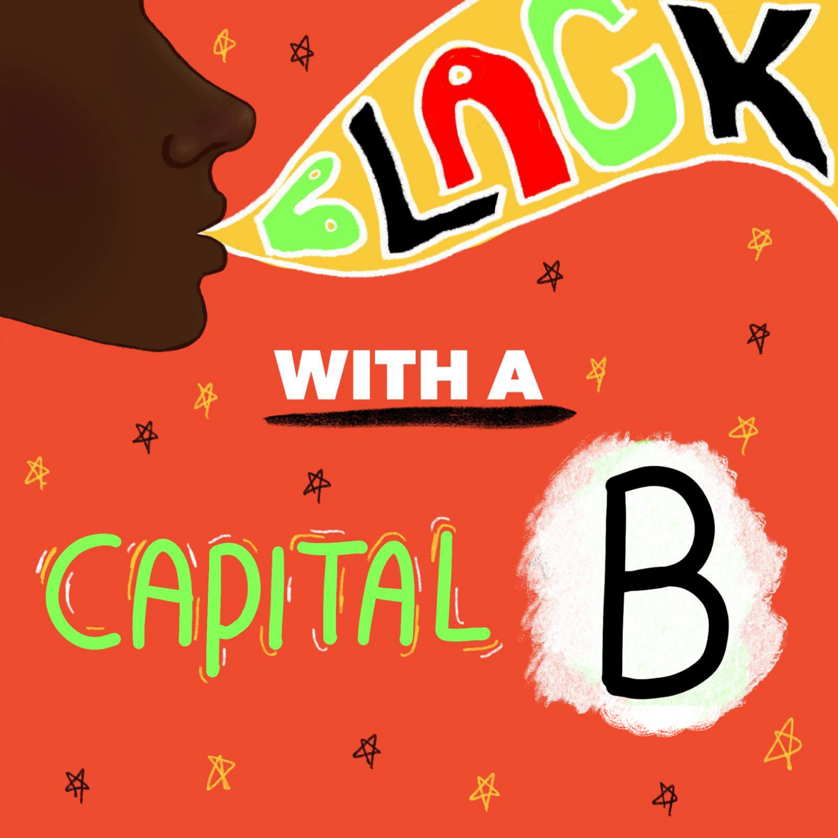

Self-Care Toolkit
For individuals who have seen, or are about to see the films

1. About Black with a Capital B
20 Stories High present... Black with a Capital B, a powerful collection of seven exclusive works by Black Liverpool artists.

The 4-year journey, led by the then Associate Artistic Director Nathan Powell (currently Creative Director at the Everyman and Playhouse Theatres), began in response to the murder of George Floyd in America in 2020. Like many individuals and organisations, 20 Stories High processed the murder of George Floyd and the subsequent events with a mix of anger, grief, and reflection. These events amplified the spotlight on racism in the UK, creating an urgent call to action for systemic change.

While diversity, equity and inclusion have always been central to the work, we recognised that we had an even greater role to play in becoming a truly proactive and anti-racist organisation. The organisation decided to use this difficult time to celebrate the achievements and highlight the struggles of Black artists, showcasing their depth, range of experience, and insight. Giving them a platform to create and share their artistry.

During the Covid-19 pandemic, seven artists channelled their voices into compelling pieces using a variety of art-forms such as music, poetry, visual art and film making and using a range of DIY tools such as smartphones, home studios, and ancestry kits. The films, made by Brodie Arthur, Tia Hume-Jennings, Malik Lidgett, Anita Welsh, Amber Akaunu, Dorcas Sebuyange and Paislie Reid have been released since 2020, each with a unique voice and powerful story to tell.

Content Warnings:
The videos contain clips and images of police brutality, racism, slavery, Black Lives Matter protests, ‘Jim Crow’/ racial segregation which some viewers may find it triggering or painful to watch. There are also mentions of racial profiling, murder, white privilege and allyship, the appropriation of black culture, colonisation and explicit language including use of the ‘N’ word.
If you need any more information about each individual film, please speak to us, or read the synopsis of each film below.

2.Self-care Definition by Carol Cumberbatch
A definition of Self Care by Carol Cumberbatch, Artist, Drama therapist, Creative Clinical Supervisor, Wellness, Cultural & Diversity Consultant:

Self-Care can be a myriad of things/activities that bring you joy, peace and/or contentment without harming you or anyone else. Self-care is an internal focus and a life-long daily ritual that can develop our emotional and psychological strength. Just like brushing our teeth twice daily contributes to good oral health, investing in self-care for ourselves throughout our days can contribute to improved emotional and psychological strength, which in turn can support us to navigate challenging situations and experiences.

Self-care is synonymous with self-compassion and self-soothing we all refer to finding ways to direct care, attention, kindness and patience towards oneself, which can alleviate distress and safely activate happy hormones; endorphins, dopamine, serotonin and oxytocin. Self-care is as unique as you are, so getting to know yourself & what brings you joy is an important first step in creating your own self-care go to activities. It could be a walk in the park, reading a book, a movie marathon that makes you laugh, listening to music or uplifting podcasts, a warm bubble bath or a cold shower, a run, being creative, having a lay in, etc...
Whatever you choose, the aim is to enjoy yourself without guilt or judgement, by gifting yourself with time to relax and recharge in different ways.

3.Synopsis of the films
1. Brodie Arthur: ‘All day, every day when you’re brown it never goes away.’
A short emotive piece in which actress, mother and business owner Brodie Arthur shares her personal experiences as a Black woman. Within the content of this piece, Brodie passionately speaks of racism, murder, white privilege and allyship, the appropriation of Black culture and the historical treatment of black people through slavery, colonisation. There is also explicit use of the ‘N’ word within this powerful, moving piece.

2. Tia Hume-Jennings: ‘BLM’
The artist Tia Hume-Jennings sings a powerful and heartfelt song expressing feelings around racial profiling and how the job of the police is to protect citizens from threat, yet the lives of Black people are often under threat at the hands of the police. Her beautiful voice plays on top of a video of images, scenes, and speeches at Black Lives Matter protests as well as clips of violent police encounters.

3. Amber Akaunu: ‘Agudas’
In this short film, Amber explores her family history and the discovery that her ancestors were enslaved. Amber poetically shares this emotional journey as she tries to make sense of the conflicting feelings of hate and gratitude. The book 'Afro-Brazilians' is featured throughout the film as it was a significant reference in Amber's research around Nigeria and Brazil's intertwining history. There are also clips of and speeches from ‘Black Lives Matter’ protests.

4. Malik Lidgett: ‘Black Man’
Malik Lidgett is a versatile music producer and rapper. In this piece he rivetingly raps about the negative trials Black people often face whilst also celebrating their resilience and excellence. Within this piece he expresses his dual heritage and his passion is showcased in his powerful delivery against a backdrop of videos from protests, police brutality and ‘Jim Crow’/ racial segregation with a juxtaposition of videos displaying Sudanese cultural dance. Use of the word S**t and the ‘N’ Word.

5. Dorcas Sebuyange: ‘Quiet’
Dorcas Sebuyange is a Congolese multi-disciplinary artist. Dorcas’ piece “Quiet” is one of the tracks from her album called DEEP CALLETH UNTO DEEP which is a collection of poetry that was written as an organic reaction to the resurfacing of racial injustice in 2020.
“Quiet” is the first piece of poetry that Dorcas wrote and during this piece she uses profoundly expresses her emotions speaking of a feeling of overwhelm and a want for justice, self-education and allyship. Statistics of inequalities between people of global majority and white people in relation to stop and search rates, arrests, home ownership, education, deaths from the coronavirus pandemic are shared in the video.

6. Anita Walsh: ‘I AM ANITA’
“I Am - ANITA” is a gift of affirmation, empowerment & strength. After the death of George Floyd, mother, poet and writer Anita Welsh felt it was important to add her voice and perspective with her own artistic response. Throughout the video Anita creates beautiful movements with her Jo/Bo stick as she recites words of affirmation to herself. This piece is a declaration to who she is while she explores her own identity. Anita’s aim with this piece is to build women up to be strong and empowered.
“I want every person watching it to be able to take an affirmation they can use to empower themselves, use positive words about themselves, towards themselves. The power is in people saying the words themselves, not me saying it for them.”

7. Paislie Reid: ‘Black with a Capital B’

Paislie Reid is a multidisciplinary artist. Her Black with a capital B is a love letter to Liverpool’s Black community through a garage song and music video. This piece talks about the struggles Black people go through on a day-to-day basis and how Black lives more than matter and it shouldn’t take death or demonstrations to prove it. It also talks about how despite the many challenges Black people still face today they still manage to rise above the limitations and expectations the world often puts on them. This piece was designed to uplift and highlight Liverpool’s own Black community which consists of very talented musicians, athletes & doctors but the message.

“I hope the take away is that they deserve to be valued and treated with respect and kindness regardless of their achievements.”

There are also images from protests.

4. Tips for Self-care (from MIND)
Self-care can be a powerful way to reject negative messages about your identity or your worth. It's something you can control – even if you don't have much time or money. You can decide when and how you show yourself kindness. And it can help build up your energy and strength.

When you feel able, here are some self-care ideas to try:

Remember your breath: If you become activated or triggered, breathing is a great way to bring yourself back into a state of calm, lower your heart rate and create space in your brain to start thinking things through at an easier pace. Try breathing in for four seconds, holding your breath for four seconds, exhaling for four seconds and holding again. Repeat this for as long as you need until your breath feels in control again. Lots of mobiles and smart watches offer apps which can help you with this. See here for other relaxation for tips.

Talk to someone you trust: Speaking to someone who understands racism can be helpful. It may be that having someone listen to you and show they care can help in itself. You may want to speak to someone you know. Or you might feel more comfortable speaking to someone you don't know.

Find ways to build your self-esteem: Try and take time to praise yourself and think about what you're proud of. For example, you could think about your character traits, skills or things you’ve done.

Take time to celebrate all parts of your identity: You could spend time thinking about what makes you happy and what you value in life. You may also find it helpful to connect with people who share your racial identity, to enjoy and celebrate your culture.

Try mindfulness: Mindfulness is a technique you can learn. It involves making a special effort to notice what's happening in the present moment – without judging anything. It aims to help you feel calmer, manage your thoughts, and be kinder towards yourself. See more about mindfulness here.

Get creative: Getting creative can help you express thoughts and feelings that are weighing on your mind. You could use dancing, making music, painting, poetry, writing or any other creative activity. More on arts and creative therapies here.

Try to look after your physical health: Recalling events can affect our body as well as our mind. Physical health and mental health are connected, so looking after one can boost both.
Being active doesn't have to mean doing sports or going to the gym a lot – although that works well for some people. But there are plenty of things you could try on any budget – and at any level of fitness or ability. You may also find that spending time in nature helps improve your physical health and your mood.

Take care with news and social media: Seeing news stories or social media content about racism might sometimes make you feel anxious or overwhelmed. In this case, you could think about switching off or limiting what you look at for a while. If a particular person on your social media is upsetting you, think about blocking them to give yourself space.
Remember: racist abuse or bullying online could be a hate crime. If you see racist abuse happen online:

Treat yourself with compassion and patience: You may find that examining your experiences is helpful at some times, but not at others. It can be good to spend a while sitting with your experiences. But it's also ok to try and take a break from thinking about them when this feels useful. Try to treat yourself the way you would treat a friend. And give yourself space when you need it.

Connect with others: Connecting and sharing with others who have similar experiences can be very helpful. You might want to meet people who share your experiences of mental health problems, or racism, or both. Some groups run in person, while others are online.
- The finding peer support page lists lots of options, including our peer support directory.
- Rethink's online support group directory shows any groups they have in your area. Some of these groups are designed for specific communities.
- Side by Side is Mind's supportive online community where you can feel at home talking about your mental health. It's anonymous, and moderated to keep it safe.
Whether you can join a support group may depend on what's available in your area.

Get Help: If you find that the above tips are not helping, you may want to consider accessing professional support. You can find below a list of organisations who can offer you help.

4.Signposting

BLACK MINDS MATTER UK
For: Connecting Black individuals and families with free professional mental health services
www.blackmindsmatteruk.com
www.instagram.com/blackmindsmatter.uk

ISLAMOPHOBIA RESPONSE UNIT
For: Reporting incidents of Islamophobia or referrals to support services
020 3904 6555
www.theiru.org.uk

STOP HATE UK
For: Reporting a hate crime after an incident (not directly to the police) or support following a hate crime
0800 138 1625
www.stophateuk.org

CST
For: Protecting the Jewish Community
Emergency no: 0800 032 3263
Support Helpline: 0800 032 8477
www.cst.org.uk

ANTHONY WALKER FOUNDATION
For: Victim support services: Racism, hate crime, discrimination
0151 237 3974
support@anthonywalker.com

TELL MAMA
For: Counselling and wellbeing support to victims of anti-Muslim hate or Islamophobia
counselling@tellmamauk.org
www.tellmamauk.org

MIND
For: A support line where advisors are trained to listen to you and help you find specialist support if you need it.
0300 102 1234
www.mind.org.uk

YOUNG MINDS
For: Providing mental health and wellbeing support for young people up to the age of 19
Text ‘SHOUT’ to 85258
www.youngminds.org.uk

SAMARITANS
For: A listening ear, to support your general mental health and wellbeing, any time of the day
116 123
www.samaritans.org

HUB OF HOPE
For: Finding the right support for you, in your area
www.instagram.com/hopenothate
www.hubofhope.co.uk

5.Well-being Apps

HEADSPACE AND CALM
Widely available in the UK, these apps offer mindfulness and meditation exercises.

MEETWO
A UK-based mental health app that offers a safe space for teenagers to discuss issues affecting their well-being, including race related stress.

6. Community Organisations and Advocacy Groups

STAND UP TO RACISM
A UK organisation campaigning against racism and supporting communities in building a united movement.
https://www.instagram.com/standuptoracismuk
www.standuptoracism.org.uk

HopeNotHate
Works to challenge and combat racism and fascism in the UK through education and advocacy.
+44 (0)207 952 1181
www.hopenothate.org.uk

