Associate Producer - Job Pack

(30 Hours - Part-Time 0.8 FTE/ 18-month fixed term)

20 Stories High
Arts Council England
Lottery Funded
Supported using public funding by Arts Council England

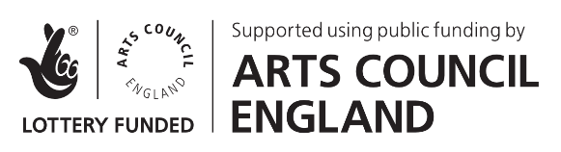
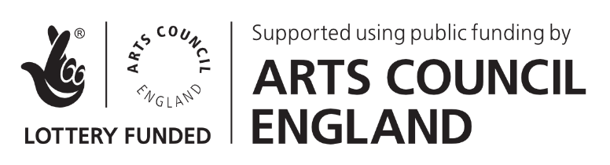

Contents of job pack:

- Welcome
- About 20 Stories High
- The Role:
  - The Programme
  - Inclusion and Representation
- Job Description
- Person Specification
- Terms and Conditions
- How To Apply

This pack is available in a range of formats including audio, large print, braille and screen reader compatible versions.

If you have a more specific formatting requirement, please let us know by emailing amy@20storieshigh.org.uk, we will try our best to provide this for you.

1. Welcome

Thank you for your interest in the role of Associate Producer.

20 Stories High began its life 15 years ago as an organisation dedicated to making theatre with (and for) culturally diverse, working-class young people in many contexts and settings. We have gone through many changes over this time, adapting and evolving to meet the needs of audiences and participants in Liverpool and nationally.

The events over the past 18 months have been a challenge for the wider cultural sector, and the individuals involved; We know how the pandemic has disproportionately affected many young people, people of colour and disabled people, therefore having a direct impact on many of our participants, audiences, and team members. We recognise and understand first-hand the barriers that exist as we begin to re-emerge in a changing world. Our focus is to support these individuals and groups to continue to engage with equitable creative opportunities in a way that feels safe and inclusive.

20 Stories High are now embarking on a new chapter: exploring what our role is within the theatre sector, co-creating with participants and emerging artists, as well as experienced theatre-makers. We are exploring what theatre and participatory projects look like in different spaces, pushing ourselves creatively, redefining what it means to be an activist organisation, and placing wellbeing at the heart of everything we do.

We are looking for an Associate Producer who can bring new ideas, energy and creativity to this new role - someone who shares our values, mission, ambition and is committed to working with young audiences and participants.

2. About 20 Stories High

Founded in 2006, 20 Stories High has established itself as one of the UK’s leading young people theatre companies. We are part of the Arts Council Englands’ National Portfolio of funded organisations, are a registered charity and have won a series of prestigious awards and commissions.

Vision

20 Stories High endeavors to create a world where culturally diverse, working-class young people and young adults' voices are equally valued, seen and heard by the most diverse audience possible.

We believe that “everybody’s got a story to tell… and their own way of telling it…”

Mission

To make theatre and art with and for underrepresented young people/young adults, emerging artists and world class professionals. To create bold, heartfelt, and unique theatre experiences that enable social change. Collaborating with young people & young adults to develop the stories they want to tell through the artforms they own and want to see.

Our 3 Strategic Aims:

- To offer excellent participatory experiences allowing access for all
- To train, develop and collaborate with the next generation of theatre makers
- To produce and tour new theatre, for diverse audiences - locally, nationally and internationally, in a variety of imaginative community spaces, and venues

Values

20 Stories High value… Equity, Wellbeing and Activism

3. The Role

The Associate Producer role is pivotal within 20 Stories High’s structure - and to its success. We are looking for a dynamic, experienced individual with bold ideas and an open mind to join the 20 Stories High team.

It is important to us that the Associate Producer shares the company’s values, and is committed to contributing to our developing practice in terms of both wellbeing and EDIA (Equality, Diversity, Inclusion and Activism).

a. The Programme

This new role will work closely as a producing team with our Co-CEO/Exec Director, Co-CEO/Artistic Director and our Youth Projects Producer to produce the 20 Stories High programme. Different projects will be assigned a ‘lead’ producer, with the others in the team taking on support/overseeing roles.

Our 2022-23 Programme includes:

- Youth Theatre: weekly creative workshops for 14-21-year-olds, leading up to a summer show in July 2022 directed by Artistic Director Keith Saha at the Unity Theatre
- Outreach: specific workshops/projects working with local young people and communities, sometimes linked to youth theatre, Here & Now or other programme areas
- Here & Now: a collection of quick-turnaround, responsive, accessible, community-focused projects, building on the success of Knocking On (2020) a doorstep theatre experience and Summer Sounds (2021) touring mini-gigs to community spaces
- Launch Academy (18-30s): professional Development Programme for future theatre-makers working with local emerging artists (in partnership with Unity)
- 18-30s Creative Programme: workshops, socials and performance opportunities (currently in development)
- Research & Development: for a new professional touring production 2023 - created by Keith Saha and collaborators
- State of Mind: Paul Hamlyn Foundation funded a 4-year programme, exploring all through the lens of wellbeing. 2022 is the final year of this funding. The focus will be on embedding the learning into our practice,as well as sharing our findings and opening up conversations
- Equality, Diversity, Inclusion and Activism programme: staff/board training, partnership working, conversations/workshops/events with young people, artists and our community - that feeds into our ever-evolving EDIA action plan, activism and overall mission of the company
- Future Collective: in 2022 we will be reestablishing a 20SH young advisory group

b. Inclusion and Representation

It is important to us that the lived experience of our team accurately and fairly represents our participants, audiences and communities we serve. We strongly believe in having a diverse team, and we specifically welcome applications from candidates from the following groups, which we believe are underrepresented in our workforce and in the wider cultural sector:

People of African or Caribbean, South Asian, East or Southeast Asian, or mixed heritage, or other people of the Global Majority (see note)

- D/deaf and or disabled candidates
- Neuro-divergent candidates
- Candidates from working-class backgrounds
- LGBTQIA+ candidates

Note: This includes but is not exclusive to people of Middle Eastern, Arab, Latinx, Jewish, Romany and Irish Traveller heritage.

4. Job Description

Creative & Programming

- Produce key projects including; 18-30’s programme, outreach projects, some Youth Theatre projects/shows, Here & Now projects/shows
- Support the Youth Projects Producer and Co-CEO/Exec Director to produce other projects/programmes, including LAUNCH, development of 2023 touring show, State of Mind activities/events- including operational tasks and hands on delivery
- Project Management of one-off workshops, events and trips for local young people and the 20SH community
- Take a lead on the recruitment and retention of 18-30’s, for specific projects 18-30 creative community and LAUNCH Academy
- Support the creative and professional development of young people and freelance artists and empower and encourage all participants
- Work with the team to ensure high-quality work across the programme
- Work with the 20SH team to ensure that all engagement and outreach activities are designed to develop and deliver 20SH’s priorities of engaging culturally diverse, working-class participants and audiences
- Contribute to - and support the facilitation of young peoples’ voices in - the ongoing development of the creative programme
- Support the delivery of the State of Mind dissemination programme
- Work closely with the Producing team to ensure the smooth running of all programme areas

Leadership

- Work with and manage freelance artists, placements and volunteers, as required
- Work with the team to ensure systems are in place, maintained and implemented efficiently, to support safeguarding of young people
- Identify and contribute to developing 20SH’s networks, to share and develop good practice
- Engage with and promote the practice, that is coming through State of Mind in terms of wellbeing for young people, freelancers, staff and partners
- Actively contribute to the development and implementation of 20SH’s Equality, Diversity, Inclusion and Activism plan and activity
- Support the company's commitment to environmental sustainability and reducing environmental impact

Sustainability and Development

- Support and maintain the development of positive relationships with 20SH partnerships and stakeholders
- Work with the 20SH team to draft budgets as required, and to deliver work within agreed budgets
- Together with the staff team, feed into the development of the 20SH business plan and support the facilitation of young peoples’ voices into the plan’s development and delivery
- Work with the team and young people to raise the profile of 20 Stories High
- Ensure 20 Stories High’s work is as accessible and inclusive as possible

General/operational

- The core staff team at 20SH is small and there is an expectation that all staff members will take a hands-on role and work together to successfully deliver the programme

5. Person Specification

Essential

- Experience and passion for collaborating with, and supporting culturally diverse, working-class young people/young adults, artists and communities
- Experience in producing/project-managing at least 3 theatre shows and/or community arts projects
- Demonstrable experience and interest in producing creative projects, that explore a variety of art forms
- Experience in developing and nurturing projects with a range of partnerships, co-producers and associate organisations

Desirable

- Experience in producing touring theatre
- Experience in fundraising for creative projects
- Knowledge and understanding of communities in Liverpool and Merseyside

Personal Qualities

- Excellent communication, interpersonal and presentation skills
- High motivation, with a flexible approach to work
- Thrive from working as part of a team
- High standards of collaboration, initiative and tact
- Good organisational and time management skills with the ability to work to strict deadlines
- Values-driven, with a demonstrable commitment to Equality, Diversity and Inclusion
- The ability to act as an advocate for 20SH, its work and its values

6. Terms and Conditions

Hours of Working: 30 Hours - Part-Time 0.8 FTE (with some evening and weekend working hours)

Contract: 18 months fixed term contract from Feb 2022

Annual Salary: £25,000-£28,000 Pro-rata (salary scale point dependent on experience)

Annual Holiday: 20 (25 days pro-rata)

Flexible working: This is intentionally a four day a week contract to enable the Associate Producer to engage in other independent work.

We are open to having conversations about Job sharing and joint application.

Responsible to: Co-CEO/Executive Director/ Youth Projects Producer

Relocation support of £500 will be available if needed.

7. How to Apply

We are committed to inclusive working practices and ensuring equal access. This pack is available in a range of formats including audio, large print, and screen reader compatible versions. If you have a more specific formatting requirement, please let us know and we will try our best to provide this for you.

We are very happy to arrange an informal confidential chat regarding the position before applying. This would be an opportunity for you to ask questions about the company, the role, or the process.

To apply for this role, please send the following:

- Completed application form available here
https://www.20storieshigh.org.uk/associate-producer-recruitment-2021/

- An up-to-date CV

Alternatively, we welcome applications in video/audio format and BSL – please send a film/audio file answering the questions within the application form (no longer than 15 minutes).

Please send your application to:

Amy Thompson, Administrator.
20 Stories High, Toxteth TV, 37-45 Windsor St, Liverpool, L8 1XE
amy@20storieshigh.org.uk
0151 708 9728

Recruitment process timeline

- Application Deadline: Friday 7th January 2022
- Shortlisting: Successful applicants will be, invited to interview by Tuesday 11th January at the latest.
- Interviews: will be held Monday 17th January 2022.

If invited to interview, we will ask you about any access requirements you might have at each stage of the process (e.g. BSL interpreter, wheelchair access, additional breaks, dimmed lights, interview questions in advance). We can also cover any travel expenses.

Thank you, we look forward to receiving your application.

- 20 Stories High

- Arts Council England
Lottery Funded
Supported using public funding by Arts Council England

- Liverpool City Council
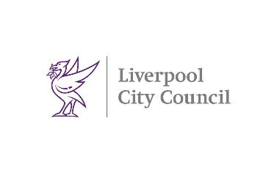
- Children in Need

- disability confident committed

- phf Paul Hamlyn Foundation
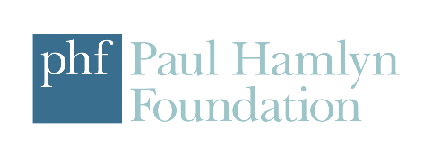

Transcribed into Etext by A2i Transcription Services
Unit 4 Montpelier Central, Station Road, Bristol BS6 5EE
01179 44 00 44 info@a2i.co.uk www.a2i.co.uk

We welcome feedback so please get in touch with your comments! Ref number: 34462

